Exploratory data analysis of Asia-Pacific conflict trends

Sean Ng

13 June 2024

Table of Contents

## Introduction

This document is intended as an overview of observed conflict trends in the Asia-Pacific region in the past ten years. For that, we have used the ACLED (Armed Conflict Location and Event Data) dataset. The reasons for privileging this source over UCDP’s Georefereced Event Dataset are detailed [here](https://risk-anticipation-hub.github.io/conflict-trends-asia-pacific/acled_ucdp.html).

Making sense of this data will require a deeper examination of the various contexts in this region. We have endeavoured to produce, rather than a template, more of a demonstration of what types of conflict analysis are possible, using ACLED data from the Asia-Pacific.

The gif below displays cumulative conflict events collected by ACLED, over the past 10 years. This is a visualisation of all the data we are working with (all observations, or rows, at least).

A few first things to note: as we will discuss shortly, the data collection has not been uniform. ACLED is dependent on resources like any other agency and will expand their services if their capacity allows it – we can see several countries pop in as conflict monitoring there comes online.

Major conflict hotspots in the region are all quite clear: Afghanistan, Pakistan, Kashmir, Bangladesh, Chhattisgarh in India, Southern Thailand, Mindanao and the rest of the Philippines, and Myanmar.

This document is no way intended to be an exhaustive analysis of conflict in the region. And in our exploratory analysis of the data, we have found the following topics/sections to provide an reasonable overview of conflict trends in the region, corresponding largely to the sections of this report:

* A review of conflict by event type: 5-year and 10-year summary charts and graphs.
* An analysis of events and fatalities per capita
* An overview of conflict in Myanmar and its spillover in the region: one of the major foci of conflict. Includes overview of most lethal conflict actors.
* An overview of cross-border violence between Afghanistan and Pakistan and Pakistan and India.
* Conflict actors
* Text mining of protest descriptions

Any analysis is limited by the knowledge of the subject matter expert and the time available. This means that there is much to be gained from both going larger (comparing regions, forms of government or economic blocs) and smaller (country-level or subnational) with this analysis. There are many definitely many avenues of exploration which we am not even aware of, given the vastness of the Asia-Pacific region and the contexts within it. This product doesn’t supplant reports from in-country analysts – who would be more accurate sources of information anyway – as they can convey the “feel” of the situation on the ground, something necessary in conflict analysis, given how diverse political conflict can be.

Nevertheless, with this report, we are, at least, contributing original research, with relatively few overlaps with ACLED’s current output: ACLED has [regional overviews](https://acleddata.com/2024/09/06/asia-pacific-overview-august-2024/) but they tend to be more punctual, bird’s eye and monthly products intended for different purposes. ACLED also adds value through its in-depth reports, such as this one on [Hindu nationalism](https://acleddata.com/2024/04/28/india-votes-2024-a-resurgent-hindu-nationalism-sets-the-stage-for-the-upcoming-elections-driving-communal-violence/) which highlight, as mentioned, how country-level analysis tends to be very specific:

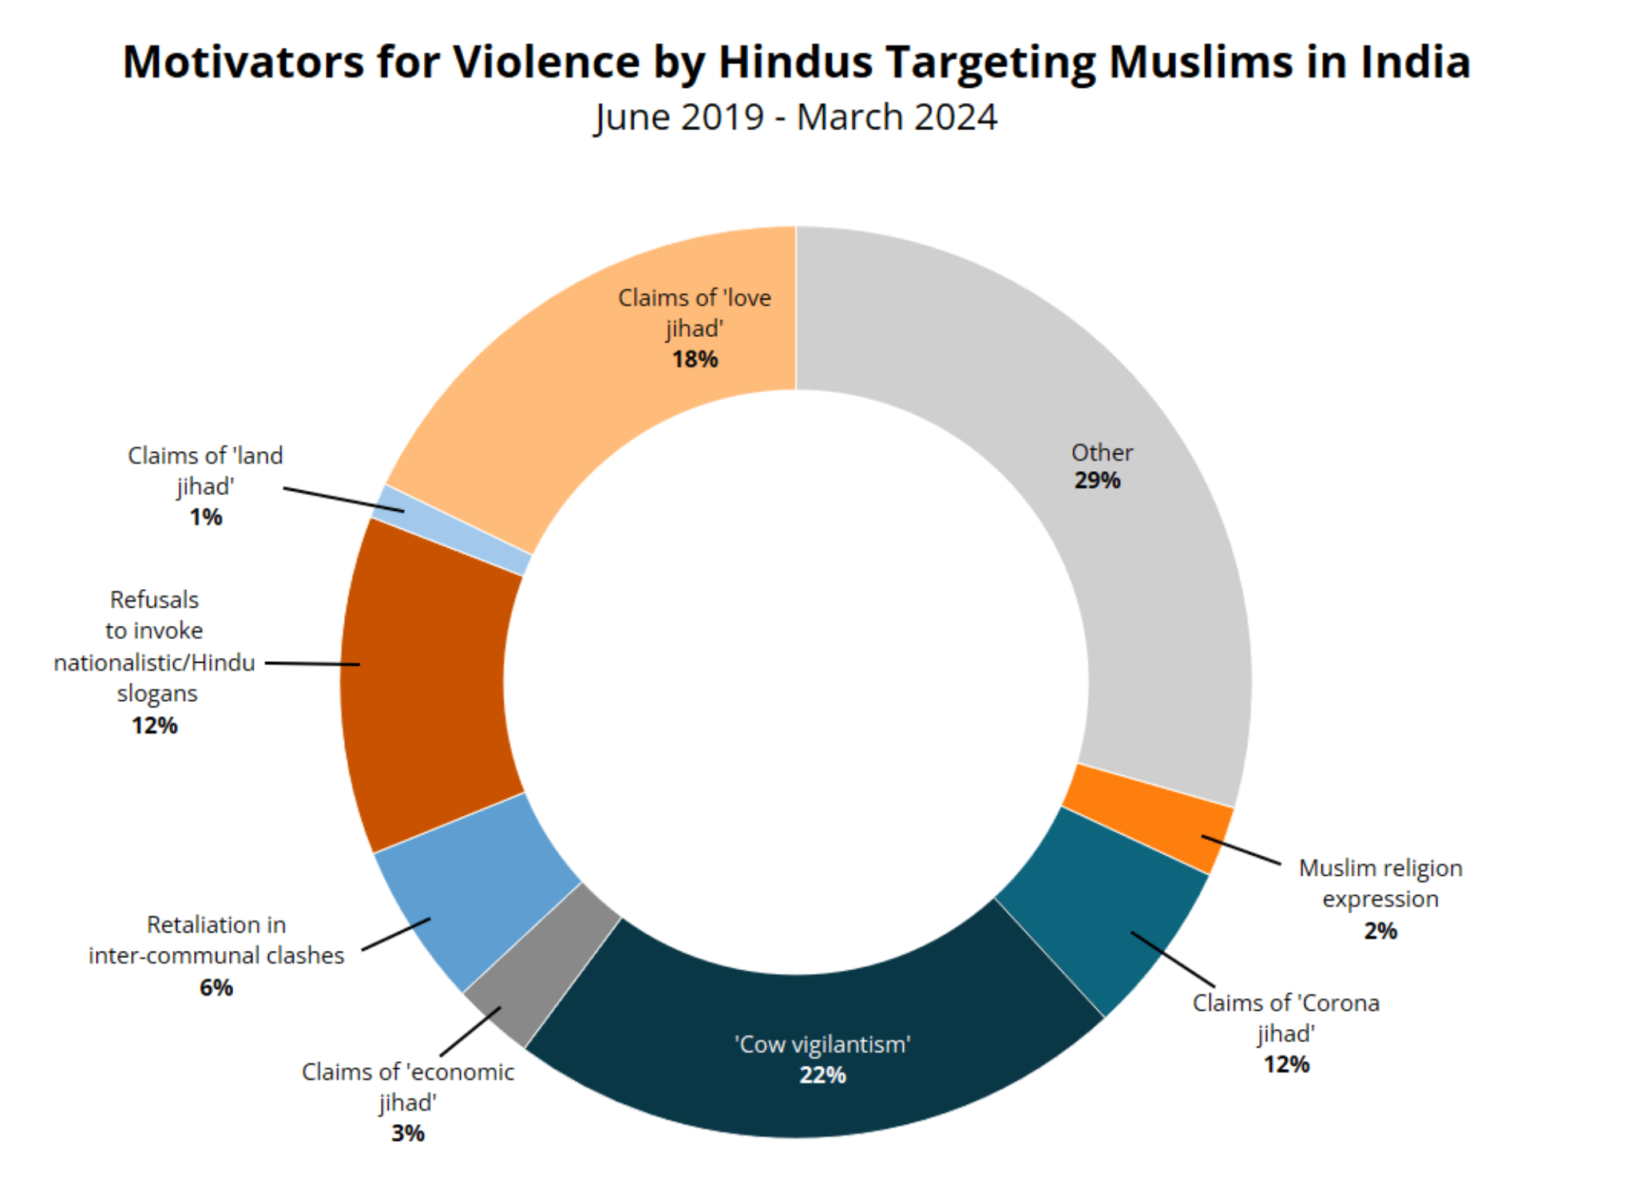

This is ultimately a living document and we seek feedback on its utility. I personally don’t feel that it is “sharp” enough to be considered an aid for decision-making. It is more of a primer on conflict in the region.

### Summary tables and trends

Below is a table comparing the the number of political conflict events and fatalities in the countries that ACLED has been monitoring since 2014. Fatalities have decreased across most countries since 2014, with the exceptions of Myanmar and Nepal. Myanmar is in a civil war and Nepal experienced severe political instability.

10 years of conflict: comparison 2014 and 2023

country

events_2014

events_2023

events_diff%

fatalities_2014

fatalities_2023

fatalities_diff%

Myanmar

899

13232

1371.86

501

16060

3105.59

Nepal

250

2490

896.00

6

10

66.67

Sri Lanka

158

894

465.82

7

7

0.00

Bangladesh

1123

2693

139.80

391

337

-13.81

Pakistan

4201

8536

103.19

5419

2333

-56.95

Thailand

1304

608

-53.37

424

57

-86.56

Vietnam

47

17

-63.83

29

10

-65.52

Cambodia

270

90

-66.67

23

0

-100.00

As ACLED expanded the number of countries it monitored, a more comprehensive comparison is possible for the five-year horizon:

Myanmar, Indonesia, Iran and Bangladesh have all experienced a significant increase in unrest in the past five years. Though unrest in these countries is less bloody than before (with the exception of Myanmar). The lethality of conflict in Pakistan has increased significantly.

5 years of conflict: comparison 2019 and 2023

country

events_2019

events_2023

events_diff%

fatalities_2019

fatalities_2023

fatalities_diff%

Myanmar

1815

13232

629.04

1512

16060

962.17

Indonesia

1644

3570

117.15

210

214

1.90

North Korea

19

37

94.74

9

12

33.33

Iran

2602

4066

56.26

478

214

-55.23

Bangladesh

1738

2693

54.95

391

337

-13.81

Japan

1299

1792

37.95

0

0

0.00

South Korea

5493

6321

15.07

0

0

0.00

Pakistan

7686

8536

11.06

1157

2333

101.64

Thailand

568

608

7.04

174

57

-67.24

India

23672

22865

-3.41

1529

1213

-20.67

Sri Lanka

954

894

-6.29

304

7

-97.70

Mongolia

94

87

-7.45

0

0

0.00

Cambodia

98

90

-8.16

5

0

-100.00

Nepal

3242

2490

-23.20

49

10

-79.59

Malaysia

224

155

-30.80

15

0

-100.00

Philippines

1901

1251

-34.19

1706

855

-49.88

China

2516

1647

-34.54

13

9

-30.77

Vietnam

58

17

-70.69

1

10

900.00

Afghanistan

8373

1465

-82.50

23413

1125

-95.19

Hong Kong

1235

96

-92.23

1

0

-100.00

The increase in the number of events – especially if it was due primarily to protests – is not an immediate cause for concern. South Koreans have managed to enact several changes through their protests (like the removal of President Park Geun-hye), as have Malaysians and Nepalese. Though these changes have also had varying levels of success.

Likewise, a reduction in events only indicates stabilisation – whether that has come about through addressing core issues or state crackdowns has to be determined on a country-by-country level.

On the whole, however, conflict events have decreased in more than half of Asia-Pacific countries and conflict fatalities are down for almost all countries, as can also be seen from the trendlines below:

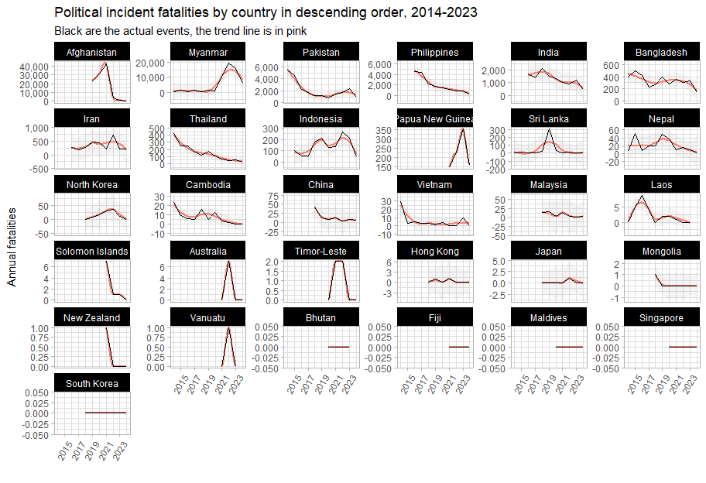

### Per Capita

Both the magnitude (number of events) and the severity (number of events per 100,000 persons) provide important perspectives on conflict: India may have a very large number of conflict events, but as can be seen from the graph below, on a per-capita basis, it sits fairly in the middle of the pack.

The plot below is of the number of events per 100,000 pe

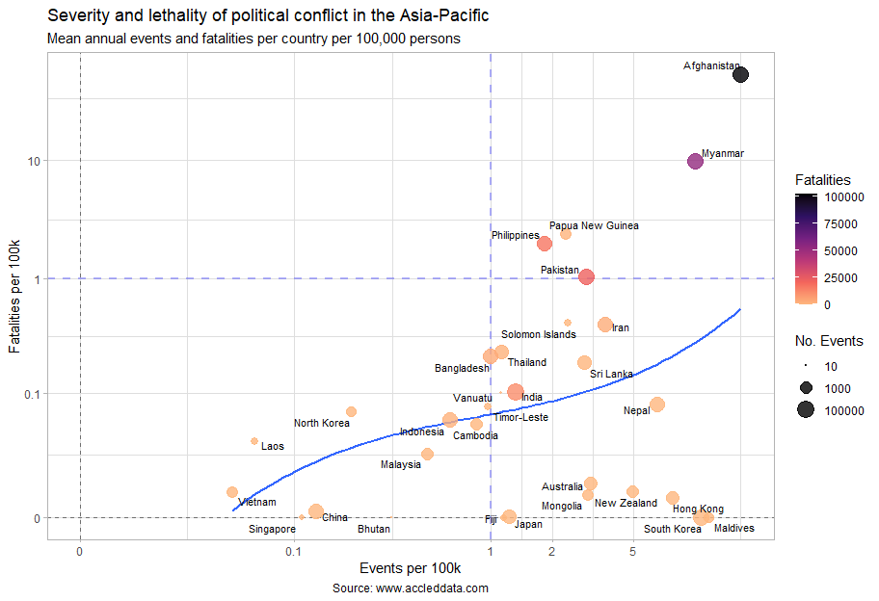

The countries most affected by political violence are in the upper-right quadrant, with distinctions between Afghanistan and Myanmar and the rest. The blue dotted reference lines were chosen just on a visual inspection of the data, but having at least one annual conflict fatality per 100,000 persons does seem to be a significant threshold. For reference and to put Myanmar and Afghanistan into perspective, the [homicide rate](https://www.who.int/data/gho/data/indicators/indicator-details/GHO/estimates-of-rates-of-homicides-per-100-000-population) in Southeast Asia is four per 100,000, and the [road traffic death rate](<https://www.who.int/data/gho/data/indicators/indicator-details/GHO/estimated-road-traffic-death-rate-(per-100-000-population)> is 16.

Most interestingly, though is the central tendency (the solid blue line) that most countries in the Asia-Pacific seem to exist on, with autocracies (or their approximations) on one end of the line and on the other, countries where violence has spun out of state control. It is unfortunate that most Asian countries seem to exist on the spectrum between political participation is dangerous and few people do it, to political participation is dangerous and many people do it.

At the bottom of the plot, not on the central tendency are the “functioning” democracies of the region (except Hong Kong). All have populations who actively participate in the political process – even the least protest-inclined of this group, Fiji and Japan, have higher rates of participation (i.e. number of events per 100k) than Indonesia or Malaysia. Yet in all of these countries, political participation does not mean death. Conflict fatalities tend to be very infrequent.

As a final note, ACLED does not capture all conflict. We use the number of fatalities per 100,000 that we have calculated from their dataset for comparison. Were we looking to calculate the mortality rate, there are [preferred sources](https://www.who.int/data/gho/data/themes/mortality-and-global-health-estimates/ghe-leading-causes-of-death).

## Event types

### Streamgraphs

#### Fatalities over time

From the chart below, sorted in order of number of **fatalities** from political incidents per quarter, it is clear that Afghanistan, Myanmar, Pakistan and Philippines have experienced severe political unrest, ranging from war, terrorism (with its hallmark explosions and remote violence) and political killings. Conflict in Afghanistan and Philippines has fallen significantly since its peak, but Myanmar is still in full conflagration and Pakistan is on the upswing:

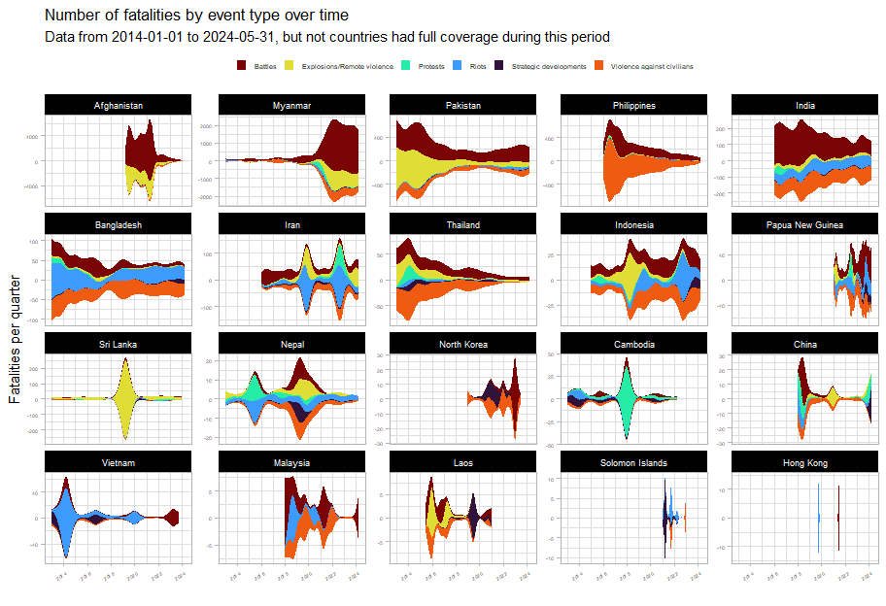

It appears that Indonesia, Iran and Cambodia each have experienced much political violence leading up to elections, though in Cambodia, the deaths associated with protests in 2018 have served as a deterrent.

#### Events over time

The streamgraphs below show the number of political incidents per quarter broken down by event type, sorted in order by the **number of political** incidents.

It should be noted that in “stable” countries, the flavour of political conflict consists mainly of protests (which indicate widespread dissatisfaction but not that all nonviolent means have been exhausted).

Widespread dissatisfaction has manifested in Thailand in 2014 and in 2021. However, the Thai state has responded by firmly clamping down on its citizenry in both instances. Core issues have yet to be addressed and it is likely that unrest will flare up again. However, the share of protests compared to violent political incidents seems to be worsening, indicating that more actors (the state included) believe that non-violent means have been exhausted.

Bangladesh seems to have an outsized number of riots. Whilst protests are a natural feature of any democracy, riots are less so, given their disruptive and violent nature. Bangladesh seems to have a higher ratio of riots to protests than any other country except Papua New Guinea; this is not an esteemed group to be in, as it speaks to the inability of the state to maintain order and the ease of inciting the population (meaning that there are a multitude of injustices to inflame).

Political incidents in Bangladesh (as we will explore in later section) had been falling until they increased around 2018, around the time of the Rohingya genocide and the influx of 700,000 refugees into Cox’s Bazaar. This, predictably, has been destabilising for the country, bringing to light many longstanding issues and grudges.

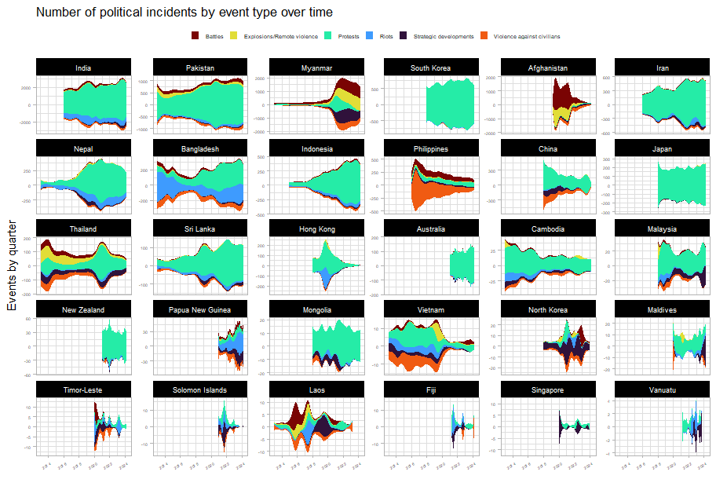

Let’s take a closer look at some countries of interest and narrow down from a ten-year horizon to a five-year one:

Myanmar and Afghanistan bear all the patterns of war. But what is surprising is the extent to which Philippine civil society has deteriorated due to damage from the drug war and the resulting political violence. When compared to other countries, their share of protests is abysmally low, lower even than Cambodia. Even as the drug war operations ceased and killings began to drop off sharply, the flavour of political unrest in the Philippines seems deeply changed, with its participatory democracy suffering massive setbacks. This is after all, not only the country of the EDSA revolution, but of the dictator Marcos as well.

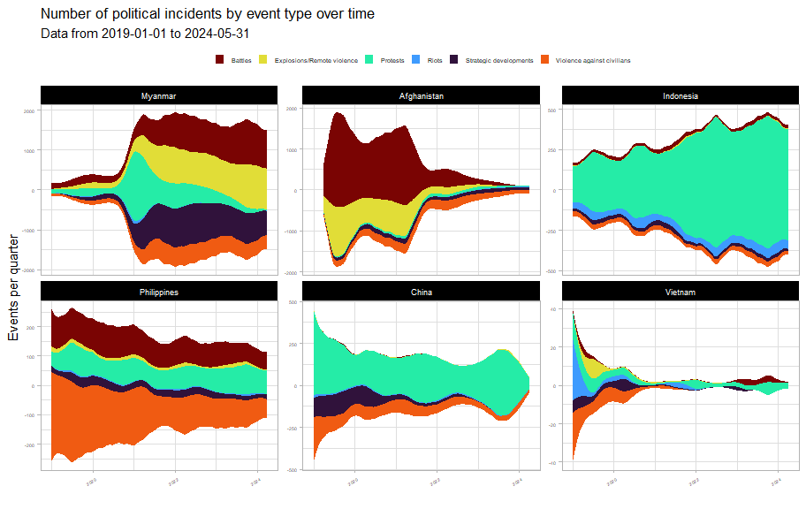

The Vietnamese state has seized the opportunity presented by COVID to advance state authority and clamp down on all types of political incidents (the clearest pattern of this in the region). China, for all the news of its vaunted lockdowns, saw a much more modest reduction in political incidents and is currently undergoing a mild increase in unrest related to labour and wage issues.

Indonesia is also experiencing an uptick in political incidents. The reasons behind this are to be explored.

In post-genocide Myanmar, with the longstanding civil war with ethnic and communal militias in the background, the population exploded in protests against the Tatmadaw’s coup. However, nonviolent means were soon exhausted and the country is now in full civil war.

With the victory of the Taliban, Afghanistan has seen a 96% reduction on conflict fatalities and a 83% drop in conflict events since 2019 levels. However, civil society has by no means recovered, nor does Afghanistan bear any of the hallmarks of a participatory democracy.

## Myanmar

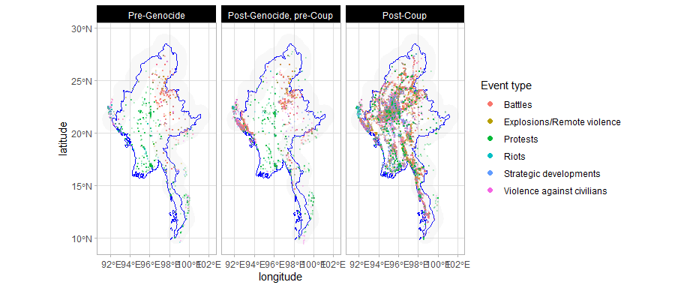

With reference to the maps above, it would appear that unlike in Afghanistan and Pakistan that will be discussed later, cross-border conflict seems to have been largely contained within Myanmar. The visible exceptions in the border regions in the map below seem to back this up, upon investigation.

First, Cox’s Bazaar already had an elevated level of political violence even before the first militaty crackdown; admittedly, there had been Rohingya refugees in Cox’s Bazaar prior to the commencement of ACLED’s data collection – and Chiang Rai: and a cursory inspection of the data indicates the majority of the recent political violence to have been driven by domestic issues, such as the cyclical election violence and calls for reforms to the monarchy.

However, the spillover from the civil war in Myanmar has been pervasive in the region. And we will discuss this in its own section below, after a brief review of the current situation in Myanmar.

[](https://github.com/risk-anticipation-hub/conflict-trends-asia-pacific/raw/main/plots/roads_conflict_black_red_combined.png)

The plots above are of the Myanmar civil war, with events (red) plotted over the road network (blue). Gold squares are Tatamadaw regional commands and the blue squares are border crossings.

Within Myanmar itself, with reference to the maps below, the fighting seems to have come to a very critical juncture. At first glance, the fighting seems to have lessened in 2024, but with reference to the line graph of monthly fatalities, we know that the fighting has instead been concentrated.

The rebels and the National Unity Government have sought to isolate military garrisons from each other; and the Tatmadaw needs to maintain its supply lines to its major command centres (as they protect border crossings, various mineral mines and other resources, such as methamphetamine factories) as well as try to project power into rebel-held territory.

This has given rise to the very linear pattern of violence as both sides contest for control over the road network. For the rebels, they have stated that “all roads lead to Naypyitaw” (the gold diamond in the middle of the country) are have been trying to enclose the military and limit its movements.

In the northeast, Lashio has fallen, drastically lowering the amount of conflict in the area. And Muse has lost five out of its ten border gates with China. In the southeast Loikaw has fallen (not a major command post, but a city at major arterial intersection in the road network) and so has the crossing with Chiang Mai at Myawaddy.

In the northwest, India has closed the border crossing at Tamu (in line with the Tatmadaw’s wishes since they no longer control it); and we also see intensification of conflict in Rakhine in preparation for the battle of Sittwe. With the northern garrisons isolated and cut off, rebels hold much of Monywa town itself, isolating the garrison there as the main front encircles and prepares to invade Mandalay.

The military no longer has the ability to push beyond the positions they already hold. If the rebels can defeat the Mandalay garrison, the Tatmadaw will have lost.

However, with reference to MIMU’s excellent ethnolinguistic map of Myanmar, if the rebels do defeat the Tatmadaw, governing Myanmar’s various ethnic groups will prove to be challenging.

### Spillover and most lethal actors

#### “Deadliest” actors

The plot below details the most lethal actors by country: these are the actors involved in events associated with the highest number of fatalities. The x-axis is the estimate for the number of fatalities from each event each actors is involved in.

Additionally, actors related to or originating from Myanmar are highlighted in red in the plot below. The widespread nature of protests, riots and violent incursions related to Myanmar. Even though armed conflict in Myanmar is largely contained within its borders, a war of this size is destabilising for the region as a whole.

The [ILO](https://www.ilo.org/media/558626/download) noted that there were 2.2 million Myanmar migrants in Thailand and Malaysia alone in 2019. It is unclear how much more that number has grown since the start of the civil war.

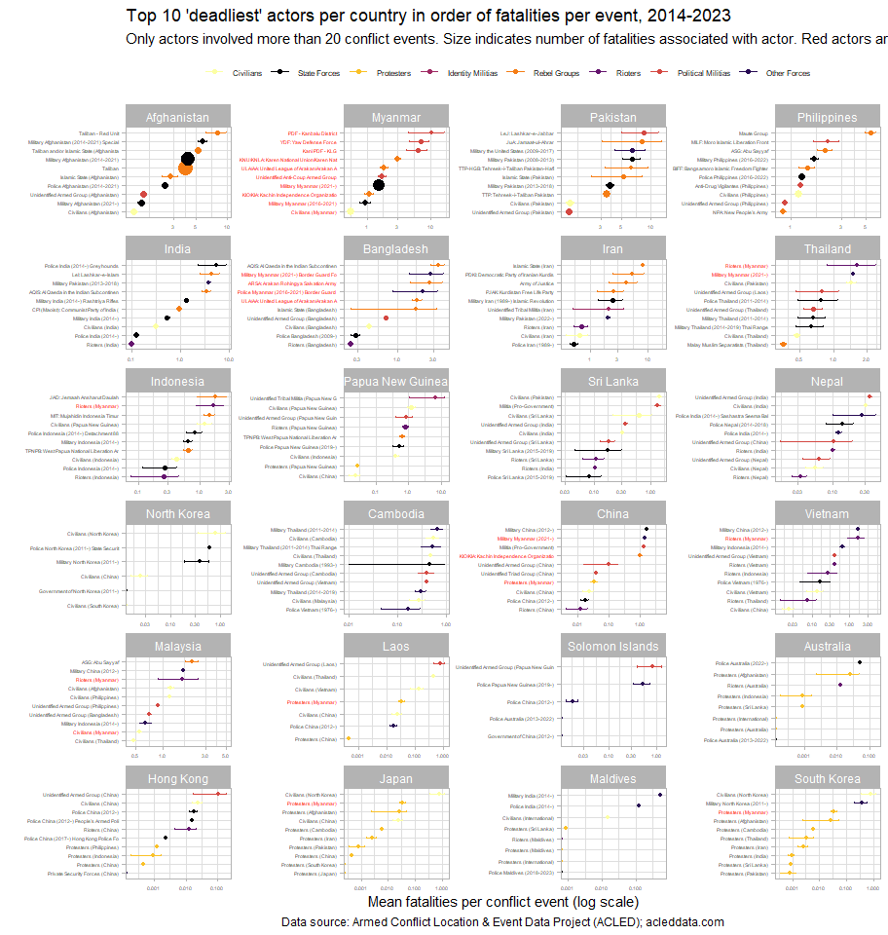

The Philippine police is more lethal than anti-drug vigilantes and the New People’s Army. Similarly, in China, civilians seem to be involved in more fatalities per event than even the police, or rioters, indicating problems with violence against civilians (as fatalities from an incident where one party were civilians and the other combatants).

South Korea here should be counterpoint to the Philippines, Vietnam and China, especially in terms of the lethality of state actors. In spite of how much Koreans protest, neither their protesters nor their state actors are amongst those who have suffered the most casualties.

## Bangladesh

Conflict in most parts of Bangladesh has been on the decline, with the notable exceptions of Dhaka and Cox’s Bazar (where the Rohingya fled).

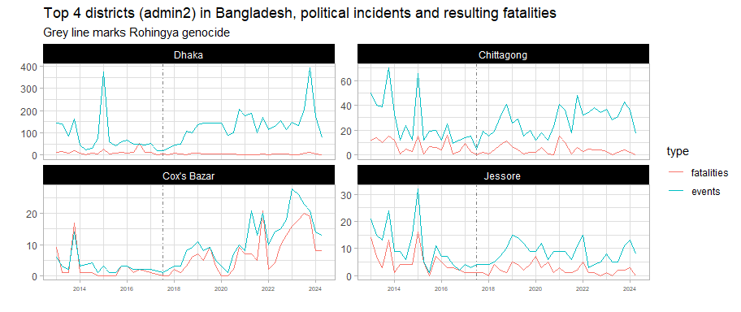

A lot more on Bangladesh

## India-Pakistan

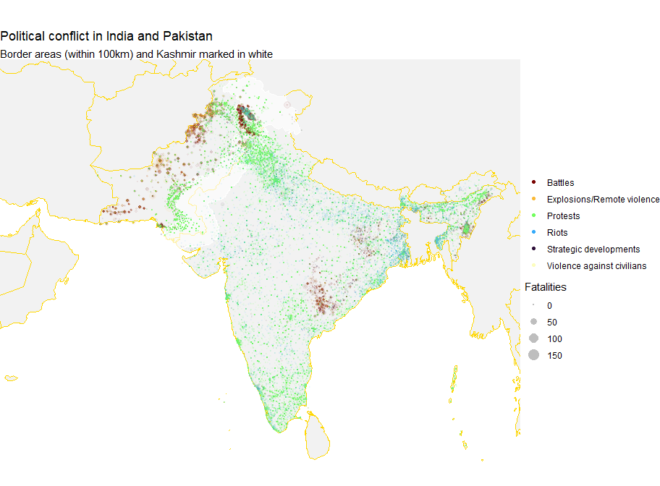

Apart from Jammu and Kashmir, the border region between India and Pakistan is sparsely populated. Though, with reference to the graphs below, the number of violent incidents in Kashmir has decreased since 2020, over the time period monitored by ACLED below, there were more battles in Kashmir than the rest of India.

Pakistan’s recent increase in conflict will be discussed in the next section.

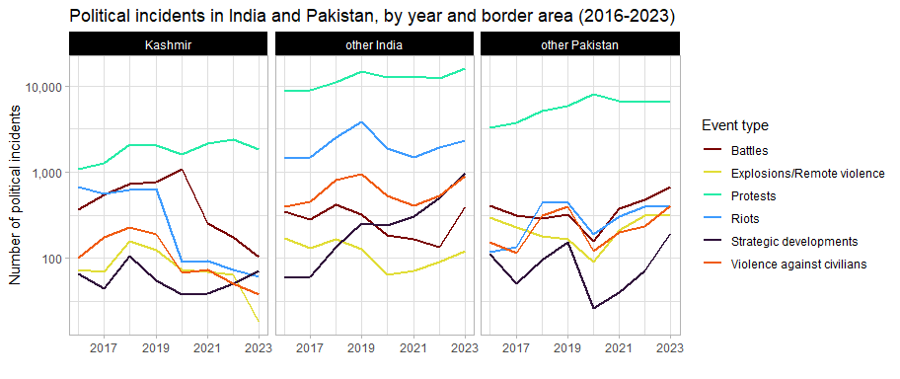

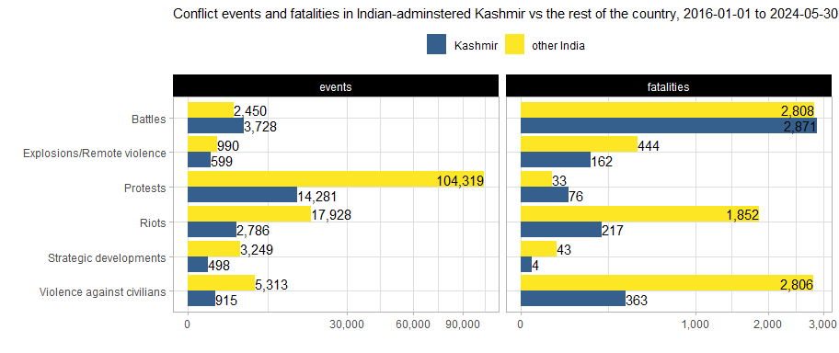

Fatalities in Kashmir have also decreased since their 2018 highs. Kashmir experiences violence against civilians and riots at a lower rate than the rest of India and Pakistan.

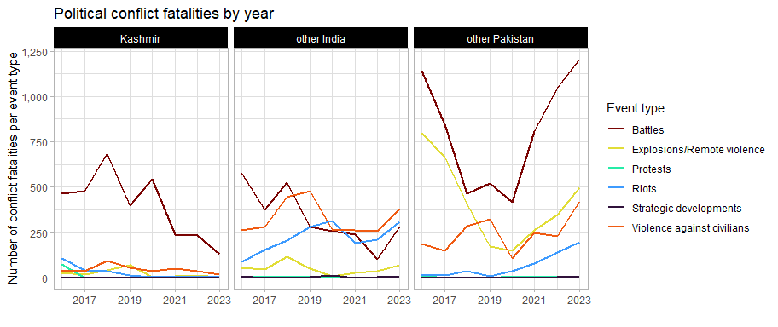

## Afghanistan-Pakistan

Even as violence in Kashmir lessens (though upcoming elections in the Indian-administered zone may change that), Pakistan is still facing tremendous cross-border pressure. The plots below show the past 5 years of conflict data in Afghanistan and Pakistan, with the border area between the two marked in a light grey.

The first three years show ultimately successful Taliban insurgency in full swing, with quite a significant amount of spillover into Pakistan, culminating in the US withdrawal in 2021. 2022 shows markedly less conflict, though we can see the beginnings of this “migration” of conflict (we don’t know how literal this is yet) from Afghanistan to Pakistan, this is more evident in 2023. This is in also line with the longstanding Taliban policy of disregard for the Durand Line.

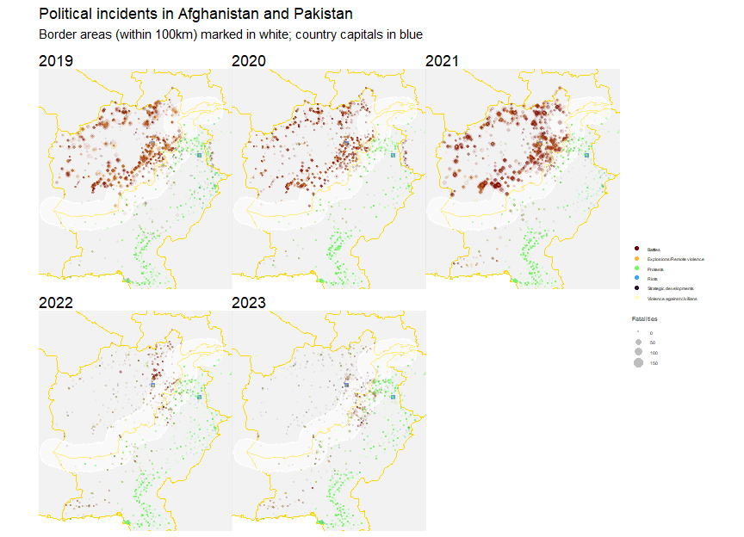

Although ACLED only began data collection in Afghanistan in 2019, ACLED data on Pakistan was extracted all the way back to 2013. This is plotted below.

Immediately apparent is how comparable the levels of conflict in and outside of Pakistan’s border areas with Afghanistan are. This 100 km-thick strip of land only lags behind the rest of the country (including the capital) in the number of protests and strategic developments.

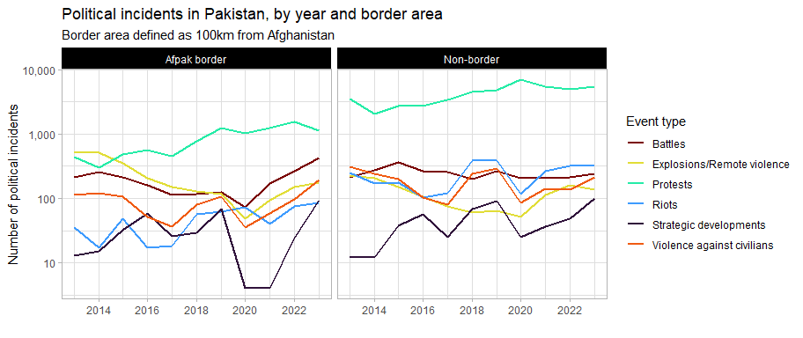

And, as observed from the maps above, we see an increase in political violence after the Taliban victory. As mentioned, this is in line with Taliban policy, but it remains to be explored how centrally-directed these efforts are.

Perhaps a more instructive view of violence in Pakistan’s border areas comes from an examination of conflict fatalities over time. Explosions and remote violence, battles and violence against civilians were once much more common in Pakistan’s border areas – this was likely dependent on the cycles of stabilisation and destabilisation in Afghanistan. This situation should be monitored for further deterioration since conflict is on the upswing.

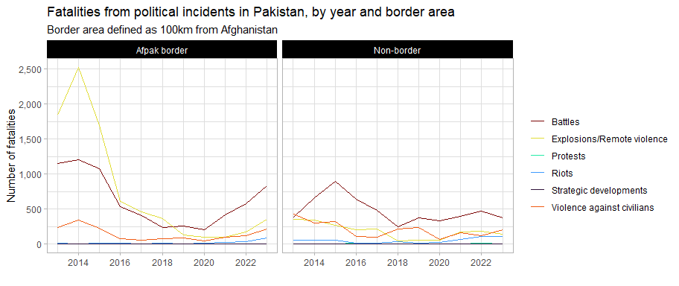

## Actors

The plot below shows the activity (events per 100,000 persons) and lethality (fatalities per 100,000 persons) of the various conflict actor types in each country. The total size of each country’s ISO code indicates the total amount of fatalities from events where each actor type was involved.

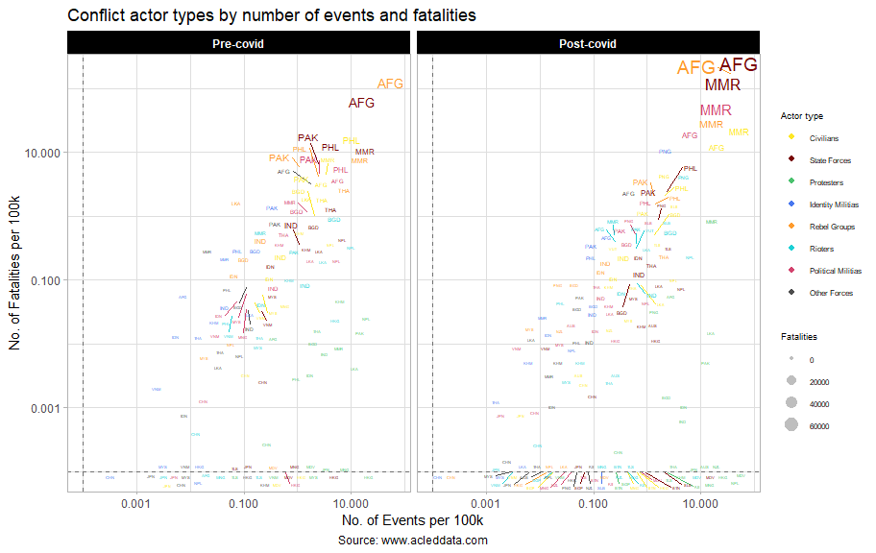

Judging by the frequency of protest events in countries not at war, pre-covid, the countries and territories with the most dissatisfied populations were Nepal, Hong Kong, Pakistan, Sri Lanka, Cambodia and Bangladesh (with its predominance of riots). Post-covid, populations in Pakistan and Sri Lanka are still voicing their dissatisfaction. For the most part, protests seem to be less lethal after covid, though Pakistani protesters had almost as high a fatality rate as protesters in Myanmar.

Protests have increased in India and Indonesia, though riots are still at the roughly the same levels as before. Maldivians (at the bottom right) are protesting at greater levels than even pre-covid Hong Kong. Pre-covid, Cambodian protesters died at the highest rate of al lother protesters.

Pre-covid, the most prominent actors in Afghanistan, Pakistan and Myanmar indicated that these countries were experiencing open warfare, given the high activity and lethality experienced amongst state forces, rebel groups, political militias and civilians (any event involving a combatant and a civilian ends predictably). Bangladeshi and Thai actors border these most prolific actors, indicating significant instability and unrest in those countries.

Post-covid, we see a rapid increase of deaths in Afghanistan and Myanmar, due to intensifying battles leading to victory for the Taliban and the post-coup civil war respectively.

Papua New Guinea, where data collection began in 2021-01-03, has showed itself to be one of the most violent countries in the Asia-Pacific.

## Protests

The most common form of political conflict is to protest. Protests are a non-violent form of political conflict which manifest when all legal and administrative avenues have been exhausted. Their existence indicates that people are able to express their support for or dissatisfaction with a given issue. But it also indicates a “hole” in governance which was previously unaddressed (and very might might continue to go unaddressed).

In this section, we explore the concerns of protesters in the Asia-Pacific. Below is a network graph of event descriptions of protests in the Asia-Pacific in the past 10 years. The links (edges) between each of the words indicate the strength of the relationship (transparency) and the number of times this word pair has occurred (thickness). Only the most common word pairs with correlations above 0.2 are included (for legibility).

The main topics identified from the graph include (cross-border issues are in bold):

* Contentious territories: **Myanmar**, **Palestine**, Korea, Manipur, **Kashmir**, **Fukushima**
* Legislation and state overreach: Citizenship amendment, Lese majeste, Oli (Nepal), Arrest, **Money laundering**
* Economic concerns: Unions, **Prices**, Arrears, Pensions, Hikes
* Service delivery and infrastructure: Load shedding, Farms, Outages
* **Coronavirus**

[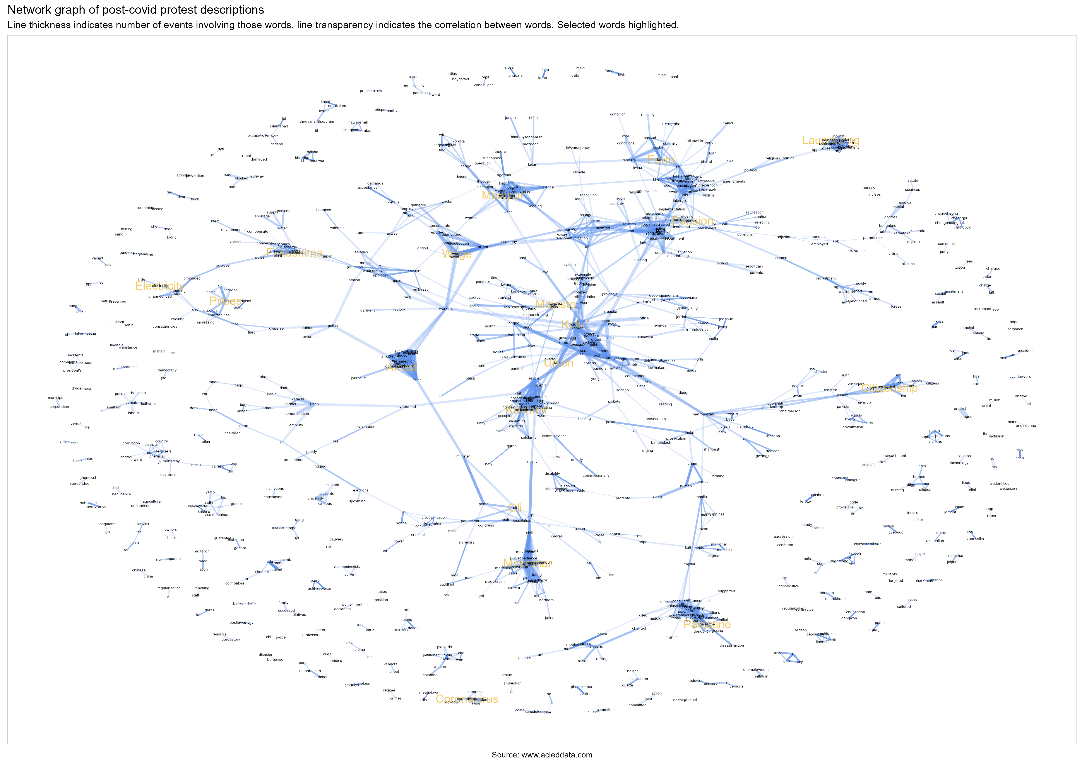](https://github.com/risk-anticipation-hub/conflict-trends-asia-pacific/raw/main/plots/./plots/protest_network_graph.png)

### Indonesia

Let’s take a look at the graph for Indonesia:

[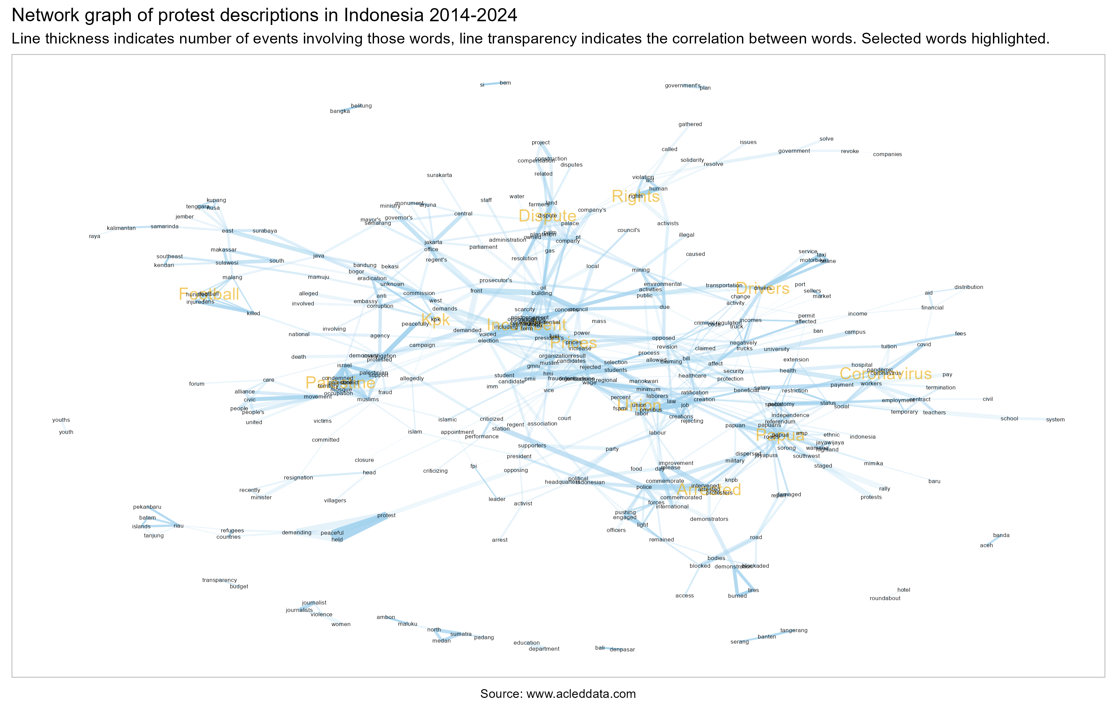](https://github.com/risk-anticipation-hub/conflict-trends-asia-pacific/raw/main/plots/./plots/protest_network_graph_indonesia.png)

Whilst the regional network graph provided a very broad overview and gave insight into common trends. I’d argue that a more targeted network graph, like this one, at the country level is far more interpretable.

### Common protest topics

The following charts, broken down by country show the (log of) odds that a word will appear in the event description (notes) for protest events in a given country.

As an example, the word most likely to appear in protest events in India is BJP.

Most topics are local or are place names (indicating significant protests in a specific area), but several common topics have been manually identified and are coloured in the chart below.

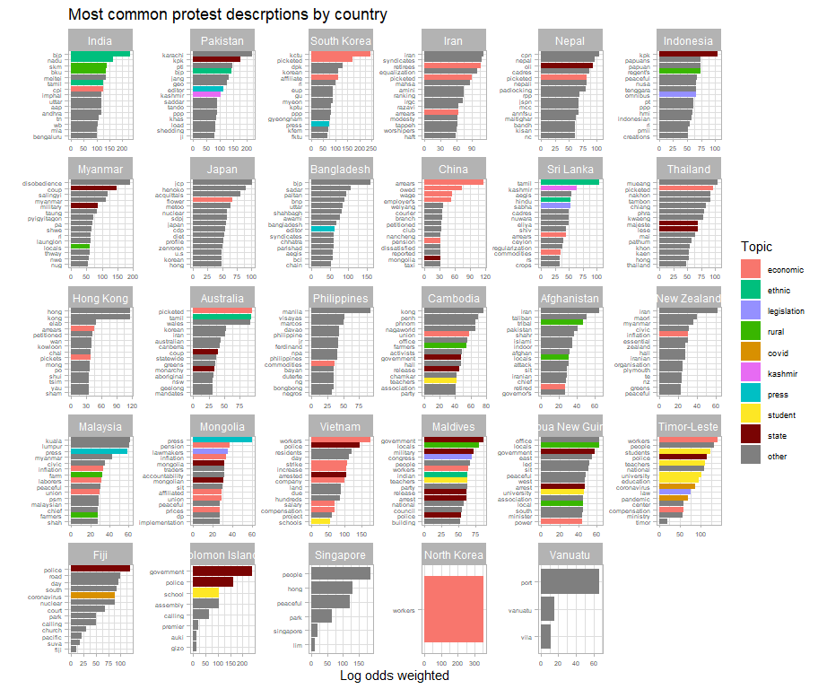

Despite all the violence in Pakistan, load shedding still appears in the words most likely to be associated with protests in Pakistan, perhaps indicating that their infrastructure is in a truly dire state, even when compared to countries of similar income levels.

Are wage protests in China a sign of a slowing economy or is it that the only acceptable subjects to protest about in China are economic issues?

## Annexes

### Supplementary charts

#### Protests vs non-protests

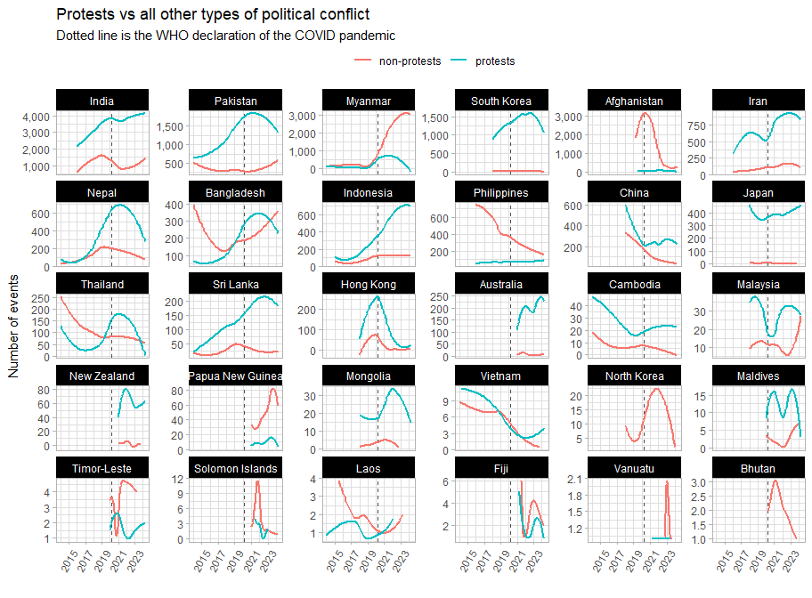

#### Actor types pre- and post-covid

